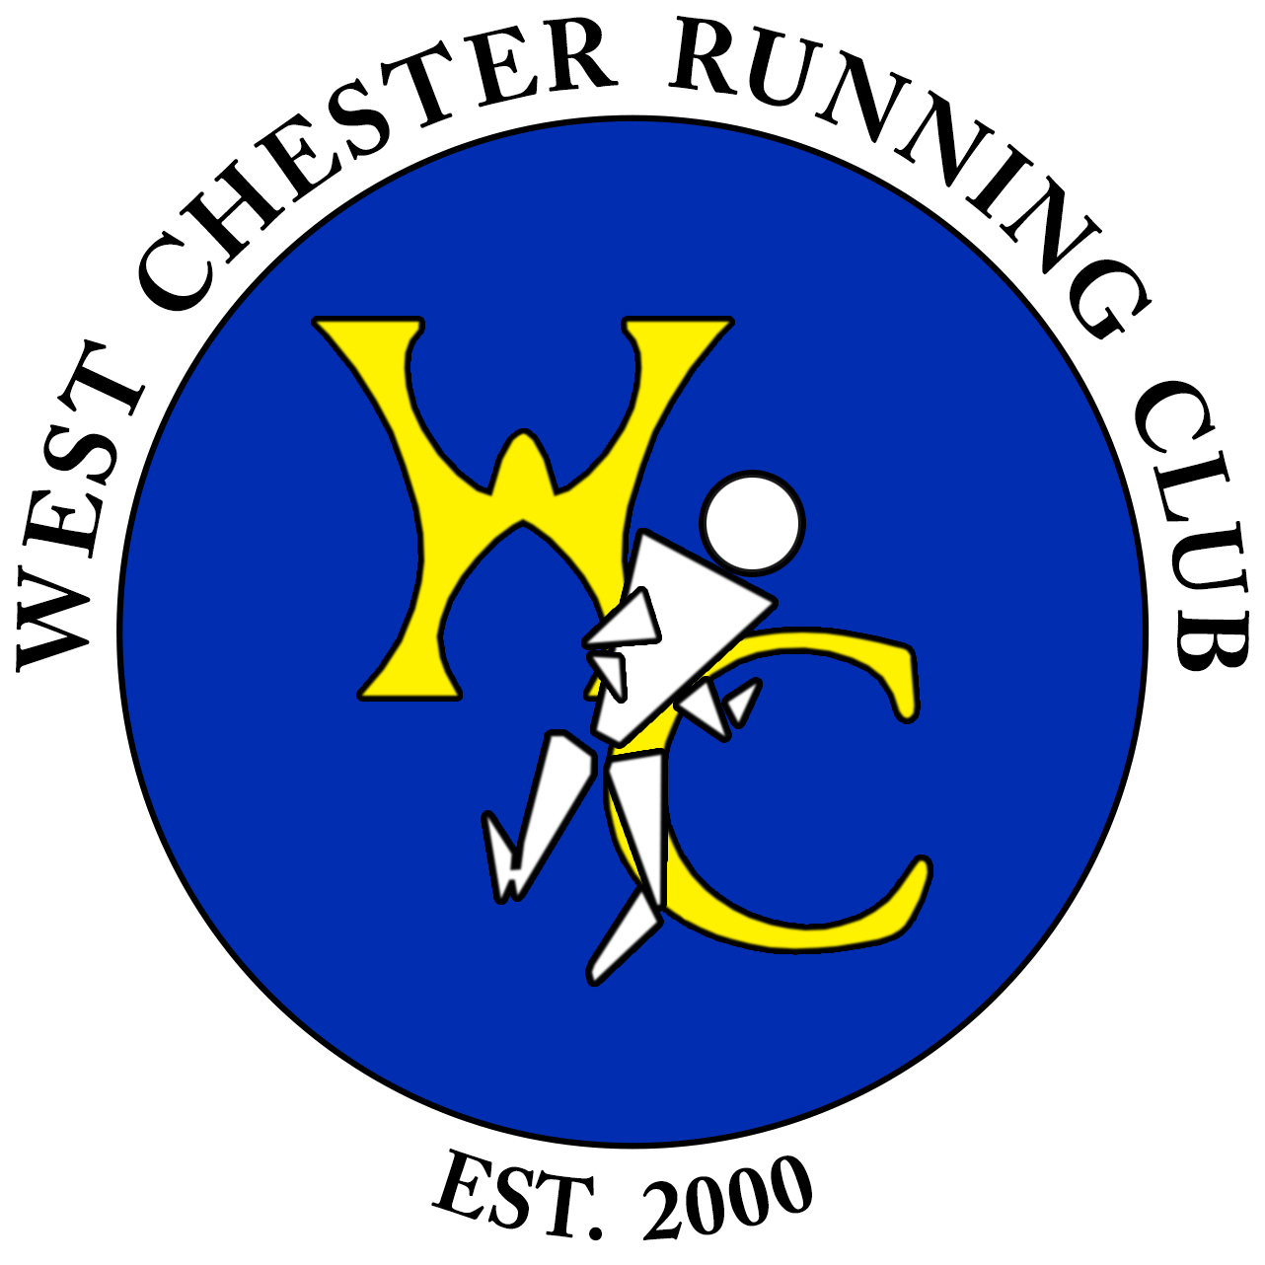

WEST CHESTER RUNNING CLUB
The West Chester Running Club (WCRC) was established in 2000 by a group of close friends who wanted to share their passion for running. WCRC promotes the benefits of health, fitness and competition through running. We support our members and the community with motivation and encouragement to obtain personal goals, create a social atmosphere and form lasting friendships. Our club is dedicated to strengthening self-image, supporting personal success, and providing a source of community involvement.
Runners interested in joining the club can view the running schedule and contact information at www.westchesterrunningclub.com .

The West Chester Running Club is awarding a scholarship for students graduating from Chester County high schools.

2025 SCHOLARSHIP CRITERIA
Eligibility Rules:
The student:
- has been accepted at an accredited two- or four-year college or university.
- has been a member of their high school’s varsity cross country and/or track and field teams in grades 11 and 12.
- has demonstrated academic excellence, athletic excellence, and leadership qualities.
- is a graduating high school senior from a Chester County, PA public or private school.
Selection will be made by the WCRC Scholarship Committee. The recipient(s) will be notified by late May and the scholarship will be awarded in June 2025.
Procedure:
- Complete the application form and essay.
- Provide the following supporting documents:
- official transcript from grades 9-11 (must be sent directly from your school’s Guidance office)
- senior year coursework and grades (report card or transcript)
- two letters of recommendation from supervising adults, which may include your principal, vice-principal, coach, teacher, employer, or religious leader (must be sent directly from your reference or your school’s Guidance office).
The signed application form and supporting documents should be emailed to wcrcscholarship@gmail.com or delivered to
West Chester Running Club Scholarship
c/o Ann Tierney
501 East Lafayette Drive
West Chester, PA 19382
No materials will be returned. Please be certain that the application is legible and complete. Receipt of documents will be acknowledged through email. Email wcrcscholarship@gmail.com if you have any specific questions about the scholarship or this application.

APPLICATIONS AND SUPPORTING DOCUMENTS MUST BE RECEIVED BY MAY 16, 2025. We cannot make accommodations for late deliveries.

WEST CHESTER RUNNING CLUB SCHOLARSHIP APPLICATION

Name: ________________________________________________________________________

Address: ______________________________________________________________________

______________________________________________________________________________

Phone Number: ________________________________________________________________

E-mail: ________________________________________________________________________

Parent/Guardian Name(s): _______________________________________________________

Parent/Guardian Phone: _________________________________________________________

High School Name: ______________________________________________________________

High School Address: ____________________________________________________________

____________________________________________________________
Varsity sports:

Grade 10: _____________________________________________________________________

Grade 11: _____________________________________________________________________

Grade 12: _____________________________________________________________________

List community service performed from Fall 2023 to present:
Description | Time spent:

List work experience from Fall 2023 to present:
Description | Time spent:

List extra-curricular activities (including offices held) from Fall 2023 to present:
Description | Time spent:

List honors or awards from Fall 2023 to present:

On a separate single typed page, write an essay describing:
- your education/career goals
- why running is important to you
- why you feel you deserve this scholarship
I certify that all information contained on and submitted with this application is correct to the best of my knowledge.

Applicant’s Signature Date

